M2 Machines Releases 1:64-Scale Lunati® Bootlegger Auto Haulers

Hidden Location, MS – Another batch of 1:64-scale die cast vehicles branded with the Lunati® Bootlegger logo are hitting the shelves.

M2 Machines has added two versions of a 1958 Chevrolet Spartan LCF with 1957 Chevrolet Bel Air inside to its Auto Hauler series. Both versions are matte black, with one featuring the Lunati® Bootlegger logo and motto, “The difference between an ‘outlaw’ and a ‘criminal’ often comes down to who gets caught,” in yellow. The limited production chase version — only 500 worldwide — has the logo and motto in gloss black.

As with previous Lunati releases from M2 Machines, each auto hauler is a highly detailed replica. They each feature die cast bodies with separate headlights, taillights and hood ornaments. They also have rubber tires and a removable die cast chassis, along with an included display base and acrylic case. All come in a wood grain package, just like the Lunati Bootlegger camshafts.

The 1:64-scale auto haulers are available from major retailers and toy stores, including Walmart, Target and Toys“R”Us, as well as hobby shops and online retailers such as Amazon.com.

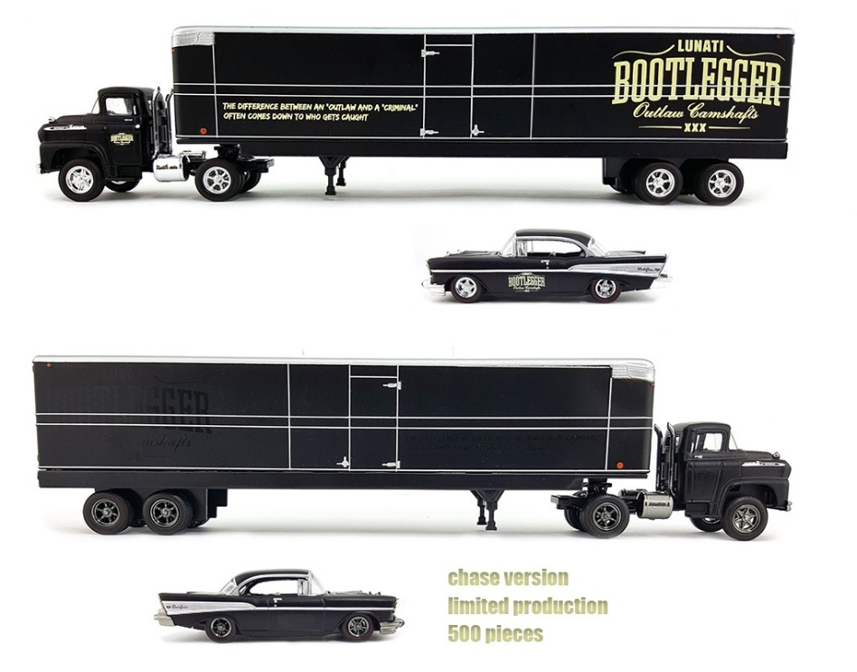

For more information about Bootlegger Camshafts, call 1-662-892-1500 or visit bootleggercams.com.

